Paddington Intercontinental Exchange
Ref. from Wikipedia:- http://en.wikipedia.org/wiki/TXK#TXK2

TXK1
This code was used for the Plessey 5005T exchanges which was a 4 wire version of the 5005 (separate pair for transmit & receive). In the UK TXK2s were only used as an international gateway, initially at Wood Street (WS) exchange in the City of London. This switch had been previously sold by Plessey to the Overseas Telecommunications Commission Australia (OTC) for use as an international gateway at Sydney. The British Post Office was planning with Plessey Ltd for a switch at Wood Street but with advanced facilities. Plessey was in difficulty with this development and could not make Wood Street work on time and in-budget. As OTC had replaced their 5005T with an Ericsson switch, it was air-freighted back to the UK in desperation to be put into service at Wood Street. The 5005T was identical to the 5005A except for the 4 wire switching, the lack of subscriber line circuits and concentration stage (i.e. no distributors).
Plessey further supplied the British Post Office with TXK2 switches at DeHavilland ISC (Burnt Oak) and Mondial ISC in Central London. The first switch was similar technically to the Wood St Relief Unit, but the latter was larger and came with the developments of Codesender Router and Line Terminations for CCITT R2 (MF(C) with E&M line signalling).
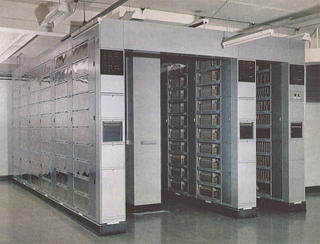
Plessey 5005T (TXK2) at Paddington, Sydney, Australia.

