OTC Veterans Loftus Tram Museum Weekday Outing
Date: Wednesday 7th November, 2012
Transport Cost: Seniors PET ticket $2.50
Museum Cost: $10 Seniors, $15 Adults No money required upfront. Pay on the day.
Seniors Special Lunch at Sutherland United Services Club: Cost: $10, About 10 choices like Fish & Chips, small Rump Steak & Chips, Chicken Schnitzel, Prawn Cutlets. Tea or coffee $2.80
Transport: Eastern Suburbs & Illawarra train (board carriage 5 of 8 car train) departs Central platform 25 (check first) at 9.12am, Rockdale 9.27am, Hurstville 9.35am, Sutherland 9.51am, arriving at Loftus 9.53am. Walk straight into museum from station platform. If this train is missed the next train departs Central at 9.25am arriving at Loftus at 10.07am. Alternatively drive your car.
10.00am Museum opens. Morning tea provided.
10.15am We start our museum tours or tram ride with our group split into 2. Ride the tram or tour 1st depending on which group you start in with the groups alternating. OTC vet Billy Jolly is our tram driver & promises a day to remember with lots of 1950’s tram memories to rekindle.
12.48pm Depart Loftus station for Sutherland station.
12.52pm Arrive at Sutherland station. Depart on western side of station. Walk a few hundred metres north from the station to arrive at Sutherland United Services Club.
1.00pm Start lunch at the club which stops serving at 2.30pm.
Regular trains back to Central leave Sutherland at 1.45pm, 1.49pm, 1.52pm, 2.05pm, 2.19pm, 2.22pm, 2.32pm & 2.35pm. The trip back takes 30 – 40 minutes. Timetables www.131500.com.au
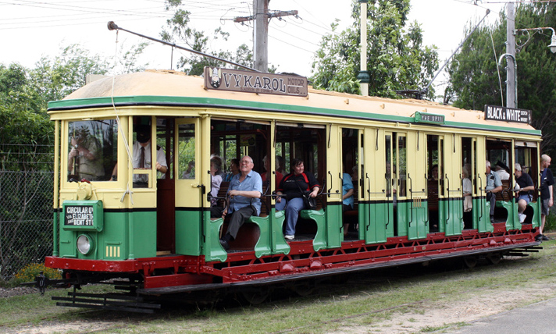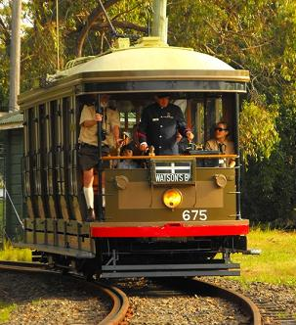
Further information & pictures from Museum website http://www.sydneytramwaymuseum.com.au
I need you to RSVP your interest to me in joining us for lunch at the United Services Club. They have put a ceiling of 25 on numbers for their Seniors lunch special . Or advise me if you wish to visit the Tram museum only. Also please advise me if you intend to drive as parking is available.
Email neilyakalis@optusnet.com.au
Phone home 98050749 Mobile 0414 228516

