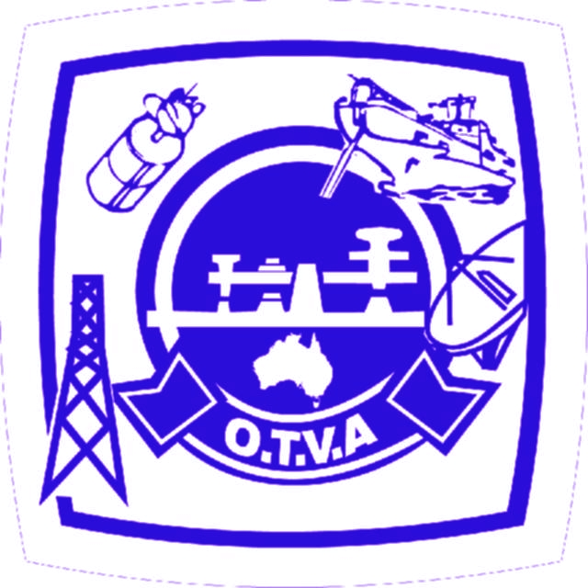
Overseas Telecommunications Veterans Association
NEWSLETTER

Registered Address: 1/284 Great North Road, Abbotsford, NSW, 2046
ISSN 1322-1906 March 2012. Volume 12 Page 21

Contents
President’s Message 1
VIP PerthRadio Museum 3
Heart Of Africa 4
Christmas 2001 Bushfires 6
Last Word 8
Submarine Coaxial Cable Testing 9
VALE 4

The Overheads
Office Bearers 20011–12
President: Peter Bull
president@otva.com
Phone: 0411 260 542
Secretary: Will Whyte
secretary@otva.com
Phone: 02 8082 5088
Treasurer: Alex Ebert
treasurer@otva.com
Newsletter Editor: Bob Emanuel
editor@otva.com
Phone: 0412 062 236 or
02 4787 5558 or 02 9332 3930
OTVA Membership Subscription:
$10 p.a. is due in May each year.
Please check your mailer as the indication “5/10" or earlier indicates that your subs are now due.
Mail Address
1/284 Great North Road, Abbotsford NSW 2046
ABN 75 502 170 235
Our Website
www.otva.com

Coming Events

2012 NSW March Reunion

Friday 23rd March 2012 at noon on the podium of Level 1 at the NSW Bowlers Club, 99 York St, Sydney.

RSVP to president@otva.com or call/SMS 0411 260 542 or by phone to David Richardson on
02 9980 8353. Interstate Vets are more than welcome.

THe OTVA Newsletter REWARDS Program

OTVA will pay a reward of $50 to members whose contribution to the Newsletter is judged by the Committee to be the best contribution. Cyril Vahtrick won the last edition's award but declined to accept.

__________________________

From Our President

Fellow Members of the OTVA,
I hope that you and your families enjoyed a wonderful Christmas and did not break too many New Year’s resolutions. I cannot believe that it is 2 months since Christmas.
Maree Giddens (ex-Reach) is organising a reunion of OTC and Reach people who have worked at the Paddington terminal or been closely linked to those who have worked at Paddington. The reunion will take the form of a picnic to be held at Nurragingy Reserve (near the site of the OTC HF Radio station at Doonside) on Sunday 11 March 2012. I see this as an opportunity for all ex-OTC staff to get together to celebrate the history of OTC and the great people who worked for it.
Your Web Master, Chris Bull, has provided statistics to your committee which shows that the OTVA web site (http://www.otva.com) is enjoying greater popularity with several hundred ‘hits’ per week. This may be a direct result of the Blog pages on the web site stimulating a lot of interest with more and more photos being uploaded each month. We collectively have many memories and stories from our past experiences in OTC which will be lost forever if we do not seize this opportunity to preserve them for future generations.
Your Newsletter Editor, Bob Emanuel, has had 6 months of illness and medical treatment which has resulted in fewer OTVA Newsletters than we would have liked but he is now back on deck and things will hopefully get back to normal so that we can continue to read with interest the news items and stories that Bob E has been able to collate for our collective enjoyment. We wish Bob E the best for continued improvement in his health.
Your Executive needs to be able to communicate with you, its membership, and to enable effective communication we need your current email addresses. We have found the increased use of email to be a very successful means of communicating with current and potential members. It is important that you advise the Committee of any changes to your email addresses to facilitate this effective communication. This can be achieved via a short email to president@otva.com. You don’t have to include any message details if you don’t want to. I will simply check your email against the one that we have on file for you. The Executive will maintain the confidentiality and security of your email address and will not issue it to anyone without your express permission.
Ted Miles made arrangements for the OTVA Committee to be addressed by the Principal Curator of the Power House Museum who is setting up an exhibition celebrating the centenary of Telecommunications in Australia. Noting the earlier exceptions to the centenary title, the exhibition will focus on the contribution of AWA, the company which was partly nationalised into OTC by the Federal government in 1946. They are seeking memoirs, artefacts and relevant details of the significant contribution of that company to Australia’s history. Any member who feels that s/he has something to contribute should contact me and I can pass this information on to the appropriate contacts.
Unfortunately several more of our ex-OTC brothers and/or their partners have departed this life since I last addressed you. I extend my sincere condolences to their many friends and family who are saddened by their passing but are gladdened by the fullness of their rich and long lives. May They Rest In Peace
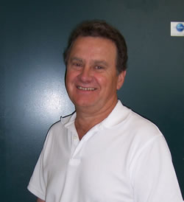

Warmest regards,
Peter Bull
____________________________

Have you checked out our website of late?

www.otva.com

With extra articles, more colour photos and more information than we can publish in this Newsletter.

www.otva.com

Have your recollections, stories and reminiscences recorded online for posterity.

If you would like to contribute to the oral history of telecommunications, please contact Bob Emanuel on 0412 062 236. Content will be uploaded to our website.

______________________

Alex Ebert is the new Treasurer

Alex has kindly volunteered to take over as treasurer for the future. Thanks Alex!

______________________

VIP Perth Radio Museum

From: "Barrie Field" <morseman@iinet.net.au>
To: <allan_hennessy@optusnet.com.au>

Subject: Our search for photographs and possibly equipment of VIP, Perth's Coastal Radio Station.

Date: 2 February 2012 16:23

Hello Allan, My name is Barrie Field, a friend of Trevor Thatcher. Trevor has given your name as a contact with the O.T.C. Museum or remnants of it.
Reason for me seeking you out is that in Perth the Wireless Hill Museum, which has existed for over 3 decades, is being radically re-organised with the aim of getting rid of mountains of equipment which is not related to the original VIP Coastal Radio station and replacing it with equipment which was related to VIP.
In other words the Melville City Council wants to turn the present museum from its' multi facetted form and dedicate it as a museum that commemorates only VIP Coastal Radio Station.
At the moment the museum is multi- facetted in that it has exhibits from the old D.C.A, e.g. large transmitters used in aerodrome/aerodrome communications, air - ground communications, an old Broadcast Transmitter from 6DL Dalwallinu, a complete Flying Doctor station complete with a pedal wireless set with Medical Chest, massive studio equipment from Perth T.V. stations, dozens of domestic wireless receiving sets, and a whole lot more, too many to be listed here.
The project is being directed by a Heritage Consultant assisted by two officers employed by the Melville City Council, at the museum, and I am only involved because of my position in the Morse Codians Fraternity as Technical Officer.
Together with our President, & Secretary, we have attended several meetings with the Heritage Consultant and her two colleagues. Our role was simply to give suggestions and help them identify items from the museum and its' storeroom.etc. There are other advisors involved as well.
One critical thing has emerged and that is that, despite the wide range of radio and telegraph equipment located and identified there is precious little relating to the original VIP Coastal Station. So the thought occurred to me to ask the persons who might be able to help with photographs of VIP Perth Radio and any information about the equipment used there.
It is important to recognise that the station VIP was at Applecross Wireless Hill from 1912 until circa 1967. Then the transmitters were located at Gnangarra until the end of the Morse Code Era. I will be proposing that the New Museum devoted to VIP PerthRadio also cover the period 1967 to the end of the Morse Code Era, showing the continued use of the callsign VIP from 1967 at the Gnangara location.
I do hope I am not an embarrassment to you, Allan. If there is anything you
can suggest regarding obtaining photographs etc. from the old O.T.C. files I will be grateful.

Regards...Barrie Field.
emails to:- morseman@iinet.net.au

______________________

Heart Of Africa
by Arthur Major

Regular readers of our Newsletter may recall my previous article dealing with life in the Suez Canal zone. It occurred to me, after some prompting by Peter Bull, that my adventures, cascading down geographically from Suez to the very heart of that massive continent, may be of interest. My position, lowly enough in the prevailing hierarchy, was nevertheless considered of some value by the pooh bahs and it was on this basis that I was enlisted as DF Calibrator in a technical party headed South. My nomination as DF (Direction Finding) Calibrator owed something to my prior Merchant Navy experience with DF.
Our Party consisted of about 20 personnel of varying rank from Flight Lieutenant down to Aircraftsmen Grade1, or AC1s. Our conveyance for this extended journey was an ex-scrapheap Dakota DC3, maximum speed 150 knots. These aircraft are not pressurised and I can tell you that at a maximum height of 15,000 feet things can get pretty parky.
The base at Deversoir served as a fighter drome but was also used as a general duty airfield for aircraft up to the size of DC3s. Deversoir is situated at the Northern entrance to the Bitter Lakes; these serve as most of the remaining navigation route to Suez and the Red Sea.
Our pilot, Des, took us up quickly from the field and I can still recall the thrill of looking down on a panoramic view of the entire canal, from Port Said to Suez. Our first stop was Wadi Halfa, at that time a small oasis type of village on the Nile, straddling Egypt and the Sudan. Maybe with a modern jet the journey would occupy a comfortable hour and a half. Our workhorse lumbered along for five hours or more in freezing cold over the hot desert below. Wadi is an Arabic word meaning Valley. I never found out the meaning of Halfa. My memories of this outpost are still fairly clear. One that stands out is of a ravishing young woman shouting out orders in Arabic to some labourers. Maybe this struck a deep chord within my pubescent frame.
Our quarters were sensibly constructed to cope with the blistering heat. On top of this we had a servant who was busily making up our beds. Time to show off my Arabic, a language common to both Egypt and Sudan. Some suitable Arabic words came to mind and I used these to enquire politely about laundry facilities. The man looked directly at me, smiling, but said nothing. My colleagues looked at me expectantly and I repeated my request. Still smiling, the man shook his head a little, then, in perfect English: “I’m sorry, sir, I didn’t get a word of that.” Well, everyone broke up into gales of laughter, including the attendant. In case you are wondering, I didn’t join in.
Having finished the calibration at the Wadi we were airborne again, setting course almost due south for Khartoum. Des felt inclined to fly low for at least part of the way. A herd of elephants panicked as this aerial monster skimmed over them in the dense jungle. Trees were brushed aside or demolished as the charging mob hurtled along. What an awesome sight. Even David Attenborough would have been impressed.
Eventually we arrived at Khartoum. As I recall, the streets were surprisingly wide for an African city of that era. And hot; did I mention that earlier? Yes indeed, Khartoum is a hot city. The twin city of Omdurman, bigger than Khartoum, lies on the Western side of the Nile and figured significantly in the Mahdi wars of the 19th Century.
Our accommodation in Khartoum was sumptuous, somewhat reminiscent of the Italian structures in Libya and built sensibly for the torrid climate.
A clear memory has remained with me over the years of a young European boy – possibly the son of some embassy official – having an animated discussion in Arabic with some waiters in the restaurant. How I envied that boy. My Arabic has remained at the Pidgin level to this day, although I can claim to read Arabic at a very basic level. But we pressed on.
Next stop Malakal, also on the Nile and halfway to Juba, capital of the world’s newest nation. Malakal at the time was a collection of straw huts, very primitive and offering a lifestyle that would have shocked most visitors. It was not uncommon to see a fully grown man walking naked along the dirt roadway. Funny how you get used to these sights. It occurred to me that Malakal, and Juba for that matter, both warranted an airport for reasons of strategic distance in what was Africa’s largest country. Juba was very similar to Malakal but lies in the south of the country, well away from the marauding Janjaweed who are aligned with the Khartoum government.
Next stop, Kisumu, on the banks of Lake Victoria in Kenya. What a refreshing contrast to the Sudanese stops. Lush country again, but tempered by the panoramic views of the largest lake in the whole of Africa. A small European population made us feel most welcome, alleviating the pervasive sense of alien-ness that had accompanied us so far. Then on to Nairobi, Kenya’s capital. Complete with cinemas, bars, a good number of restaurants, newspapers even. Up in the highlands, Nairobi is quite cool and it is easy to understand why Kenya as a whole had, and still has, a strong appeal for tourists.
Our last stop on the southern leg was Tabora in Tanganyika, renamed Tanzania after the incorporation of Zanzibar. There is absolutely nothing memorable about this desolate outpost, save for the fact that it was the southernmost extent of our journey into the Heart of Africa.
The return trip took in Somalia, Eritrea and Aden. Mogadishu, the capital of Somalia, lies just north of the equator and looks out onto the Indian Ocean. In my time it was populated by an interesting mix of Italians, Somalis and British military forces, with a sprinkling of other nationalities. A dangerous place, nonetheless, particularly for any intrepid Italian who chose to stray from the main centres. Stories of horrible mutilations were rife in the bars and coffee houses of Mog, as it was known.
Air force personnel in the Middle East received a weekly free allowance of 200 cigarettes. I recall naively opening a flap packet of 50 Players and placing them on the drinks table in a beachside bar. Many eager Italian fingers relieved me of the entire contents within seconds. Oops!
From Mog, we flew north to Aden on the south western tip of the huge Arabian Peninsula. I can’t remember any work being carried out there. For us it served as a dormitory for the daily flight across the Red Sea to work at Hargeisa, also in Somalia. In all my travels around this planet I have never encountered such a desolate place. Think of a few withered saltbush scattered across a stony desert terrain under a leaden sky, that just about sums up Hargeisa. Our cargo consisted of a number of wooden crates filled with fresh produce for the benefit of the brave souls serving in that outpost of outposts. Having completed our work at Harg, time to move on to Asmara, the capital of Eritrea.
Asmara has a lovely climate, thanks to its altitude and distance from the coast. A little bit like Mog, but on a smaller scale. One could get into trouble easily in Asmara; the local girls were particularly alluring, especially after quaffing the local libation, I forget what it was called.
A souvenir from Asmara remained with me for many months after we arrived back in Egypt. The last I saw of this garment was when it was raised on the parade ground flagpole in Deversoir to the surprise and fury of the officer commanding. But that’s another story.

______________________

Christmas 2001 Bushfires

By John Vossen

(John had left Telstra Reach by this stage and was the NOC Manager for Hutchison Telecoms).

Christmas Day 2001 in Sydney arose bright and sunny and very hot. All the warnings had been issued for days regarding the dangers of the hot westerly winds expected and the fuel on the ground in the bush all around Sydney and in the State of NSW.
We had a family gathering at our home in Woronora Heights near Engadine in the Sutherland Shire located in the south end of Sydney, basically on the way to Wollongong. Some of my family had travelled from Wollongong and Canberra to be with us that day.
As the day slipped into afternoon the temperature and westerly wind kept rising and a fire had started in the west of Sydney sending smoke and ash toward the CBD.
Then about 3pm the unbelievable happened and another huge fire was travelling rapidly from the west through the Holsworthy army reserve and towards the Heathcote National Park.
In its path were the townships of Waterfall and Helensburgh. By about 5pm as the visitors were ready to leave for Canberra and Wollongong.
A number of TMAS (Technical Message Advice Service) messages from the NOC (Network Operations Centre) had been arriving during the afternoon indicating the damage to the network was building and increasing the problems as the fires spread. Hutchison Field Operations Staff - also known as FOPS - were out trying to restore power to the sites that had lost power but were still working on the batteries. They do this by towing a generator to the site and attaching it via an external plug/socket arrangement and switch.
Meanwhile the family that had left for Wollongong had returned because there seemed to be lots of ambulance, fire trucks and police about. We agreed that nobody should travel and we settled everyone down for the night. We later found out that the Aged Care Centre at Garrawarra near Helensburgh and other facilities were being evacuated and the Old Highway and F6 Freeway were closed indefinitely. The FOPS staff were stopped at Sutherland and had to return to base. The fire to the south was massive and looked like a volcanic eruption with ash and burnt leaves falling from the sky into the backyard. The view from our roof as the sun set was incredible.
A rough night was had by all as my pager kept the information flow rolling in when sites failed because the batteries went flat (see the weekly report on the OTVA website). Single sites are one issue, and customers can work off other sites given that the signal strength is there, however major hub sites like Helensburgh when they fail take out the whole string of sites beyond them because of the interconnecting communication systems back to the switching centre.
Around 4am I called the NOC and proposed a plan to restore Helensburgh given the clearance by the authorities. The plan was for the recall field staff to rendezvous at my place for breakfast on Boxing Day and hatch the plan from there. The South recall field staff member was Ho Hung Na aka “Hosi” by the NOC and Field teams.
Hosi turned up and we listened to the radio reports over breakfast. Previously I had tried the local Police and SES with no luck for clearance to travel into the area, under any circumstances.
Hosi left the generator out front of my place and went for a reconnaissance around the area. He popped back and said he would hang around the Sutherland Shire SES and Rural Fire Control Centre at Heathcote, with the Telstra and Optus guys to see what happened. We agreed to stay in contact and he took the generator there.
By about 2pm the situation had worsened and after a talk with Steve Searle (Manager Field Ops North) I went round to see how Hosi was doing with the Fire guys. Hosi showed me the fire from the railway overpass bridge and it did not look good, the flames could be seen from there leaping into the sky. The Telstra and Optus guys left. We stayed around the now locked doorway to the Centre and watched the events.
A group of reporters had turned up and bold as brass demanded an escort to Waterfall for some pictures, and off they went and with an escort. A pregnant lady and her husband turned up and wanted to get home, they were sent to Sutherland Hospital. A rural fire service lady of high rank had helped them. Hosi indicated he had spoken to her and that she was very helpful. I asked her that if reporters can get in, why couldn’t we, with an escort, to restore an essential service. She was very surprised we were still there and promised to find an escort. The rural fire escort arrived and gave us strict instructions to follow only his advice and to stay close to his four wheel drive vehicle, we agreed and thought the way was clear.
It took ages to get past the Police roadblocks, on the F6 and after having clearance from John Hallis (Manager Operations) and talking with Gordon McGill (my Manager on holidays in Victoria) until we dropped out of range we went forward to the forth and last roadblock. This is where we had to wait for the road to be cleared of power lines, by this time we were about 100 meters from the fire and the smoke and flames were that close. The wind direction was driving the fire across the road. Finally the Police let us pass with the escort and Hosi drove the car through the smoke while the flames were basically leaping over the car, he stayed to the far left of the road because the fire was over on the far right of the dual carriageway freeway. We had the vehicle air-conditioner on full and recycle, however the radiated heat from the flames could be felt through the glass. We passed the bad area and then into Waterfall town-ship, it was quite shocking to see the bush so devastated, luckily most of the houses were fine with the fire right to the door. The fire crews had work very hard to save the homes. Fire crew were mopping up spot fires and clearing the road of fallen trees. The escort left us at the Woronora Dam turn-off and we went on alone to the site.
Hosi was shocked to find two huge trees still on fire had fallen into the compound and we could not gain access to the shelter.

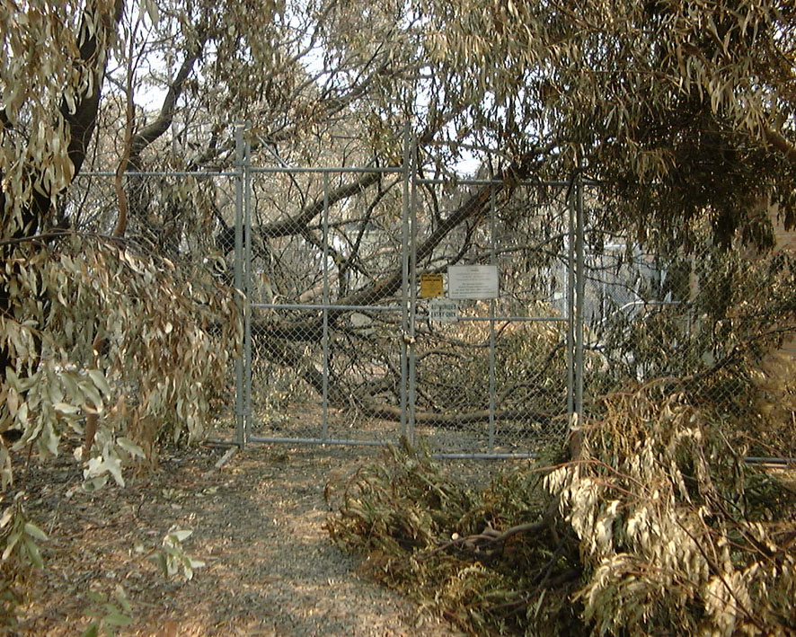

Hosi set up the generator outside on a burnt area and I tried to find a way in. The tree was blocking the gate and entry.
We broke the branches to get past and again on the second tree to get to the door.
One worked outside the compound and one inside, connected the diesel generator and fired up the site. A few test calls later, to the NOC and Jason, another of the field guys working that day, we started to head back, wondering aloud how it would be travelling back but this time on the other side of the road closer to the flames.
We bumped into another fire crew putting out spot fires, I asked them to go to the end of the road and put out the burning trees in the compound. They agreed.

I received a NOC notify page to indicate that the Waterfall site had failed due to flat batteries. This site was on our way back out of the fire area but it is still well in the fire zone. Jason had a generator and he was on the way. The plan was to meet at the Waterfall site.
Travelling back seemed fine, we just waved to all the roadblocks and by this time we had on the bright red and yellow jackets and started to look like part of the furniture. Bad news by way of a phone call, Jason was not allowed through the first roadblock and was stuck back at Heathcote road junction. Another plan, let's just go and get Jason!
We zoomed into the first and major roadblock and while Hosi performed a U-turn I told the Police manning the roadblock that Jason was with us and we had just come from out of the area and needed to return with the power supply. He was waved through, and follow us, via the phone, was the call to Jason. Fairly quickly, this time, we talked our way through the next few roadblocks and was held again at the forth. A young police lady escorted us to the Waterfall site, but had no intention on staying with us, so left us to do the job. Jason hooked up the generator, and fired up the site, which seemed a little slow to come back. Hosi was on the roof in no time replacing the GPSR antenna to solve the problem.
All done we left the site and returned to the Sutherland Shire SES and Rural Fire Control to check out and head home for the rest of Boxing Day.
Back at home Chris (my wife) asked me “Have a nice day dear”? Yep.

(Vosso, a great tale - I had to restrict the excellent pictures you sent me as they would not show up all that well in black and white. They will be, however, shortly on our website).
______________________

Last Word

Many thanks to all Vets who sent their best wishes upon hearing of my sudden illness and hospitalisation. It was painfully horrific and took 5 weeks (4 hospitals and 7 doctors) to come under control.
The follow on was pretty awful and only now is it really under control.
I am sorry that I could not get the OTVA Newsletter out, but that's what happens no-one volunteers to be a back-up. Any volunteers?
______________________

Vosso's great story of the 2001 Christmas Day fires struck a great chord with me as he mentions his manager, Gordon McGill. Gordo, his wife Anita and my wife Deb and I became great mates when we worked together in Kuala Lumpur for Time Telekom.
Gordo has had a brilliant career, culminating in a spell at Ericsson's HO in Sweden, where the local version of our ABC did a half hour documentary on him.
The photos and NOC Log extracts John refers to will be on our website shortly.
_____________________

Keep an eye out on free to air television in the March-April-May months as your editor was chosen to co-host a "paddock to plate" documentary about a restaurant reasonably familiar to most of us. The shooting took place in January, and, as you will see, was fairly active. I haven't had that much fun in years!
______________________
Vales will be published in the next edition. I thought it more important that Henry's article, below, be published.

Submarine Co-axial Cable Testing and "Clark's Fall of Potential Test"

By Henry Cranfield.

(This bit of OTC history is rather technical in nature, but it really shows what we were made of, how OTC folks made a difference in international telecommunications. I consider their collective wisdom in this issue as legendary - Ed)
This article was written as little acknowledgment in later years was made in OTC of the skills required to obtain accurate coaxial cable fault locations and I am indebted to Cass Cousens and Dick Pitt from C&W, Peter Whisson, Trevor Thatcher and Percy Day from OTC for their help and encouragement which raised my interest in the subject which I still have.
The first submarine telegraph cable was laid from England to France in 1849 and the first Transatlantic cable from UK to Canada in 1868, The cables provided far more problems than those used on the land, due to the use of poor insulation (Gutta - Percha) and the poor purity of the copper used in the conductors which greatly attenuated the signals causing the galvanometers employed to hardly move. Also the high capacitance resulted (due to the use of Gutta - Percha as the insulation material) in a time lag and mutilation of the signal sent The original methods employed to overcome these problems were to raise the voltage of the transmitted signals which in itself caused problems due the poor insulation. Peak voltages up to 2000V, being employed. The second proposal was to improve the receiving instrument’s sensitivity.
Two Englishmen, William Thomson (Lord Kelvin) and Edward Whitehouse examined the associated problems with Lord Kelvin determining that the strength of the signals followed 'The Inverse Square Law' and he published a paper on same. Whitehouse disputed Kelvin’s claims and said that high voltages were the requirement. He used an induction coil and voltages up to 2000V for transmission, which enabled the use of a standard galvanometer at the far end to prove his point. However, the high voltages used caused cable failure and was abandoned.
Johann Gauss and Wilhelm Weber invented a 'Mirror Galvanometer in1833 which enabled telegraph signals to be detected and displayed by a point of light. It was far more sensitive than those used at that time. This instrument was used by Lord Kevin on the first transatlantic cable and Lord Kelvin developed his own instrument later..
Kelvin’s galvanometer coil gave greater sensitivity and enabled very small movements of the coil to be used by means of a reflected light source. This he patented in 1858. It was still used as a detector in DC cable testing until the mid 1970’s. The capacitance problem was resolved by using positive and negative voltages of the same magnitude to represent dots and dashes. This required a special key with two levers to send the required polarity and to ground the cable between pulses and it was known as a 'Cable Key' and was used until the ceasing of the systems in the 1950’s. Thompson also invented the siphon recorder that used an ink jet and enabled the signals to be written down on a tape and usage of this was licensed to the various cable companies

D.C. Cable Testing. On Coaxial Submarine cable Systems.
To measure cable break locations, well known D.C. telegraph test techniques were employed using a 'Wheatstone Bridge and Mirror galvanometer as a balance indicator' together with accurate standard resistance boxes and capacitors (Usually 1 or 2 microfarads) These tests required considerable skill on long cables to achieve accurate results, especially where varying 'Earth Currents' were encountered.
It was also found that due to modern coaxial systems having composite inner conductors of copper and steel, some of the formulae used previously were not applicable. Another factor was that the much improved insulation materials used, increased the capacitance and this caused a long time-constant.
Fault location apparatus known as Submarine Repeater Monitoring Equipment (SRME) such as those supplied for the Compac and Seacom cable systems also proved unsatisfactory due to the capacitance of the cable making the pulses virtually unreadable. In the case of SRME 15 &17 used on Seacom, even the use of a high quality oscilloscope as the detector, required many hours of fruitless effort as one had to count the number of repeaters viewed (99 repeaters between Madang and Cairns). The most successful tests employed were the 'Overlap Tests' of Anderson and Kennelly or that modified by Johnson & Schonau. With intermittent disconnections of the inner conductor the method of Wald can be used or 'Murphy’s mixed Charge test'. These were all developed for submarine telegraph cables which had solid copper conductors. These tests required much skill at both ends of the cable to obtain satisfactory results.
Further problems were caused by the valve repeaters. The heaters in valve repeaters heat up by the passage of the test current. This causes an increase in resistance, which complicates the location if current is applied for more than a minute. (The cold value of the resistance of a repeater is measured at 5 milliamps and is given in the splice sheets). The time it takes for the system to cool down to enable useful measurements to be taken is 16 hours. In the case of transistorized systems the measurements are still taken at 5 Milliamps.
As the dielectric resistance of modern cables is very high 'Fall of Potential Tests' may be used to locate dielectric faults and give very accurate results. It must also be acknowledged that power feed readings of voltage and current at the time of the break, may also give an approximate location. System safety is also of paramount importance as the high insulation resistance enables high voltages to remain on the system unless the ends are earthed.
The Fall Of Potential Test.
In 1863 Latimer Clark put forward the 'Fall of Potential Test' which was superseded by the 'Overlap Test' twenty years later. This came about due to leakage and poor dialect resistance of the insulating material. One further factor was the inability to measure, accurately and speedily, very small voltages, until the advent of the digital voltmeter.

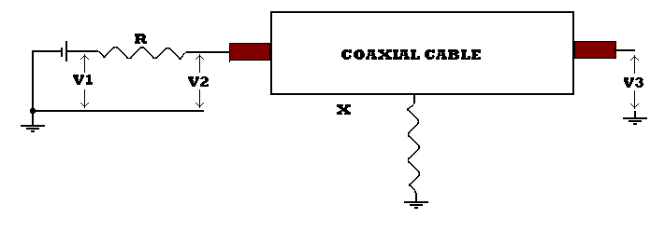

The principle is very simple. A battery is connected between earth at one end of the cable through a known resistance ( R = 10,000 Ohms) and earth, the distant end being free, (See Figure 1) the potential to earth is measured at the points indicated.

The current flowing through the resistance and the cable, up to the fault, is equal to:

(V1-V2/R)

V3 is the potential to earth at the fault, so that (V2 – V3) represents the voltage drop along the cable to the fault. By Ohms Law, R= E/I so that the distance to the fault is:

X= R(V2 - V3)
V1 - V2

This formula assumes that the potential measuring device has infinite resistance.
However, the input resistance of the meter may cause problems due to errors introduced in the location of the fault. This problem may be overcome by using the following formula:

X = MR(N(V2-V3 ) –V3L
MN(V1-V2 ) - (R ( NV2 + MV3 ).

Where M&N are the resistances of the meters at the near and far end of the cable respectively and L is the approximate CR of the faulty cable.

The Value of “R”
It must be noted that the accuracy of the value of “R” must be known as the accuracy of the location is dependent on this. Thus the value of R must be measured by means of a “Bridging Measurement' and if under 10,000 ohms made up to this figure by means of a resistance box with 0.1 ohm steps. If over 10,00 ohms then the figure obtained from the 'bridging measurement is used in the formula.

Earth Potentials.
It is most necessary to measure earth potentials. Difference always exists between the ends of the cable due to natural phenomena beyond the testers control. These must be measured with respect to the cable and corrections made for same when measuring the applied voltage.
When the polarities of the earth and the applied voltage are the same, the former must be subtracted from the latter, and when they are opposites they must be added.

Effect of the Meter Input Resistance

In the practical case as in figure 2, if the potential measuring device, M, draws any current at all, V2 and V3 will be reduced due to the additional IR drop, across R and V3 will be further reduced by the voltage drop due to the current flowing beyond the fault through Y.

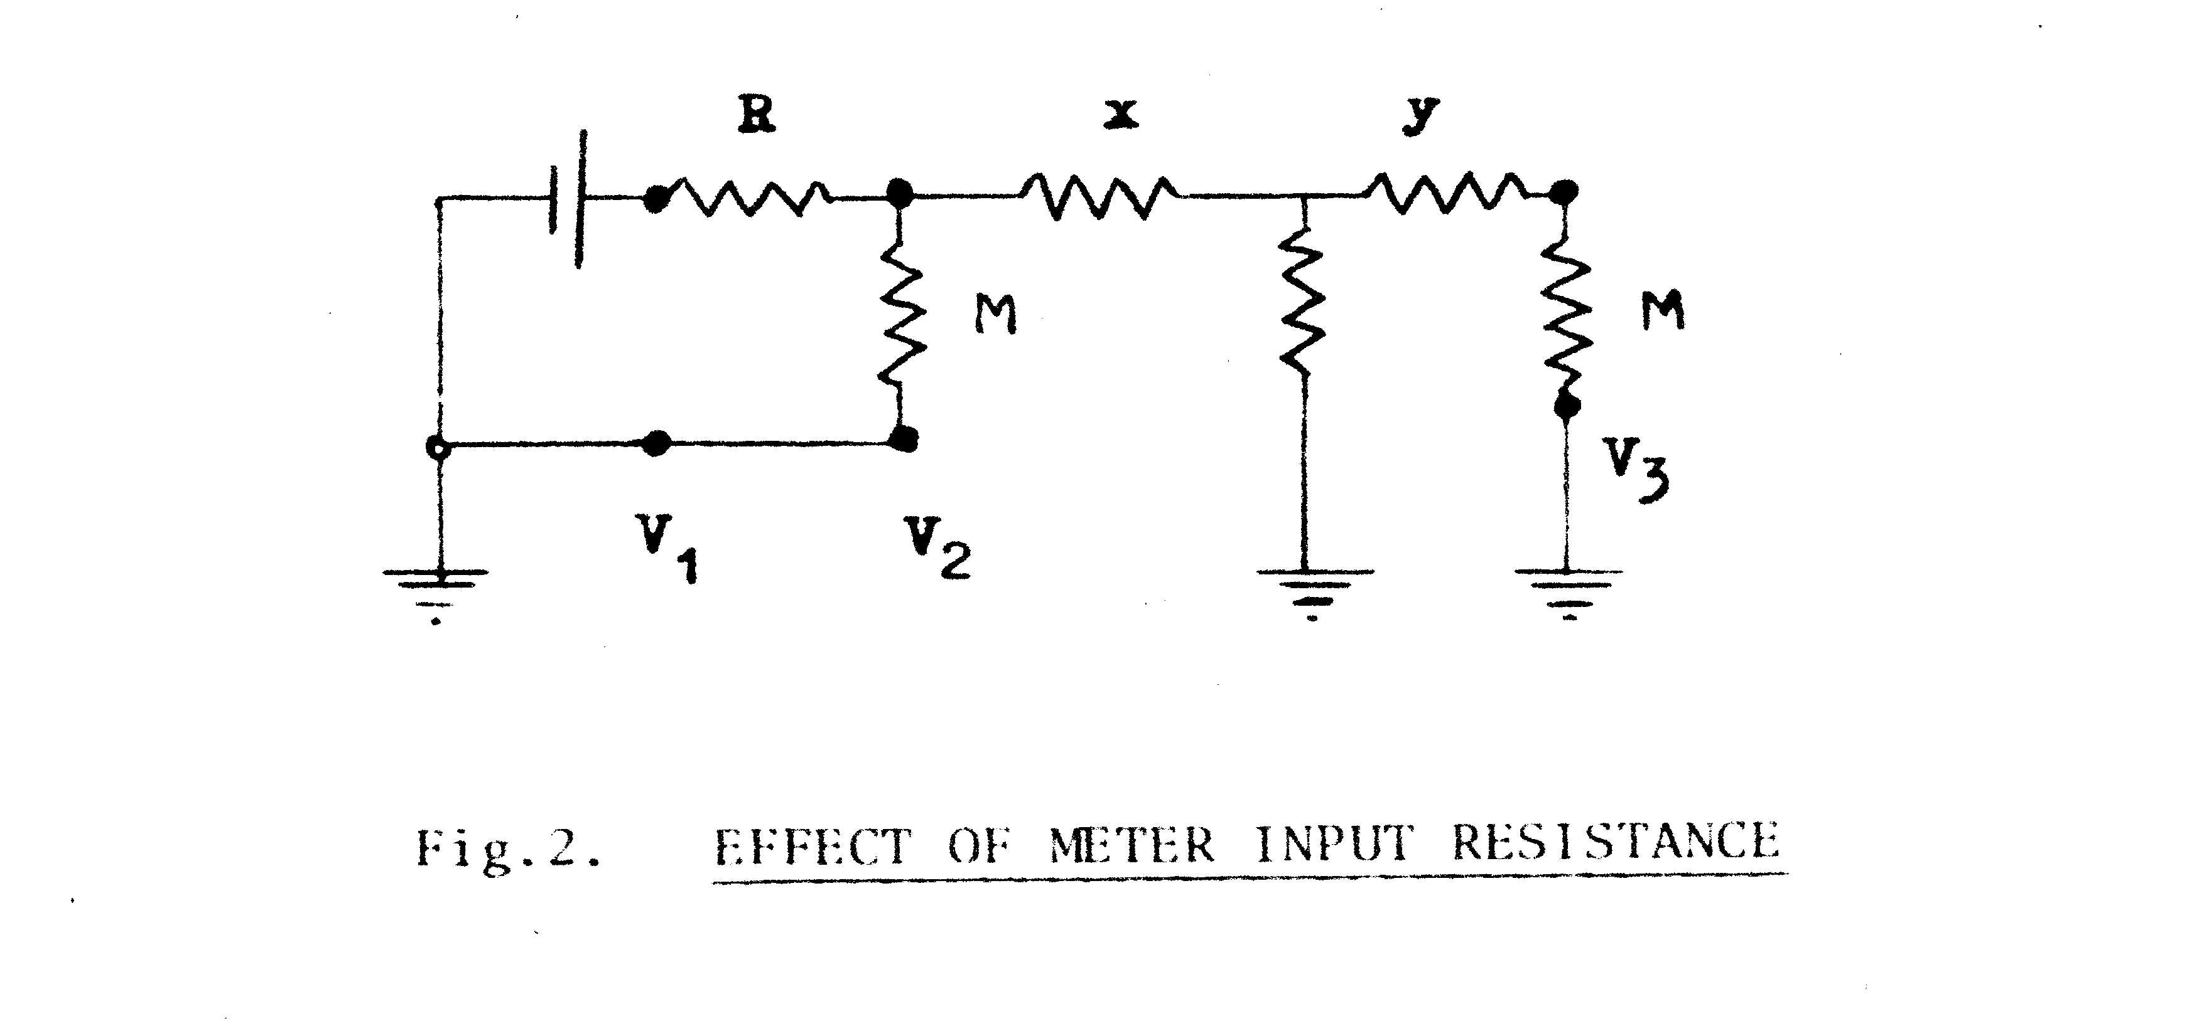
Fig 2 Effect of Meter Input Resistance

Seacom Experience.

At Madang, we had a number of breaks in the Cairns–Madang section due mainly to earth tremors.
One particular afternoon we suffered a cable 'trip-off' and instituted the normal practice of sending messages via Guam and putting our Radio Transmitter 'on air' etc.
We then conducted normal DC tests and despite all our efforts, neither Cairns nor us could get a fault location. So we awaited the arrival of the C&W cable ship 'Retriever' for more expertise. They too came up with Nil result. So after Dick Pitt, the cable engineer, talked to London, it was decided we would try Clark’s Fall of Potential test. This required a digital voltmeter for Cairns and Madang which was forwarded from Sydney and Trevor Thatcher was dispatched to assist in Madang, We also learned it was necessary to do a large number of readings and average the results for the final figure. So I went down to our local surveyor’s office and borrowed a 'Facit' mechanical calculating machine, while the 'Retriever' lent us a junior cable engineer to help with the calculations .We finally located the fault as being off Lae and the cable ship brought up the cable to find that the centre conductor had been parted. However, the heat that had been generated at the time of the break, had caused sealing of the break, hence we had an open circuit within the cable sheath. It appears that this was a rare happening and the cause was put down to debris from the Markham River which was in flood due to it being the wet season pushing debris out to sea which caught a repeater and pushed it down the slope on the sea bottom as it is the perimeter of 'The Solomon’s Deep'
It was the first time ever that the test had been used anywhere and the piece of cable was sent to C&W in London for their museum. We felt quite excited as it was a world first and since adopted as a standard test on coaxial cable systems and is also incorporated into the new 'Tinsley' cable test-set which does the tests automatically.
Thus OTC, through Des Kinnersley in Cairns, Trevor Thatcher and your writer in Madang, achieved a 'World First'. Something we are very proud of!

Developments
With the introduction of transistorized coaxial System repeaters and Fibre optics, there has been much research carried out and the testing made semi-automatic, thus eliminating the skills previously required. Also the introduction of transistorized repeaters and Fibre optics, together with improved instrumentation, simplified the former manual skills and brought about greater accuracy and longer cable lengths. The UK instrument makers, 'Tinsley' from the UK, in conjunction with Cable and Wireless (C and W), have now sophisticated test sets to cover these requirements. Having had the luxury of trying their Mark 1 version on a Guam –Tokyo cable, for which Pat Cousins of C and W was the principal consultant, much progress has been made but it all comes at a cost.
Seacom Cable Physical Characteristics
The Cable was known as Lightweight Mk.1 With a diameter of O.99 inches
Inner conductor Resistance 2.9 Ohms/nautical Mile
Outer conductor Resistance 1.5 ohms/nautical Mile
Dielectric Resistance greater than 0.5 X 10 Meg Ohms/Nautical Mile
Breaking Strain 7.7 Tons
Weight in air 2.2 Tons/nautical Mile
Weight .in water 0 .6 tons /Nautical Mile
Mean Characteristic Impedance at 50 KHz. 44.5 Ohms

